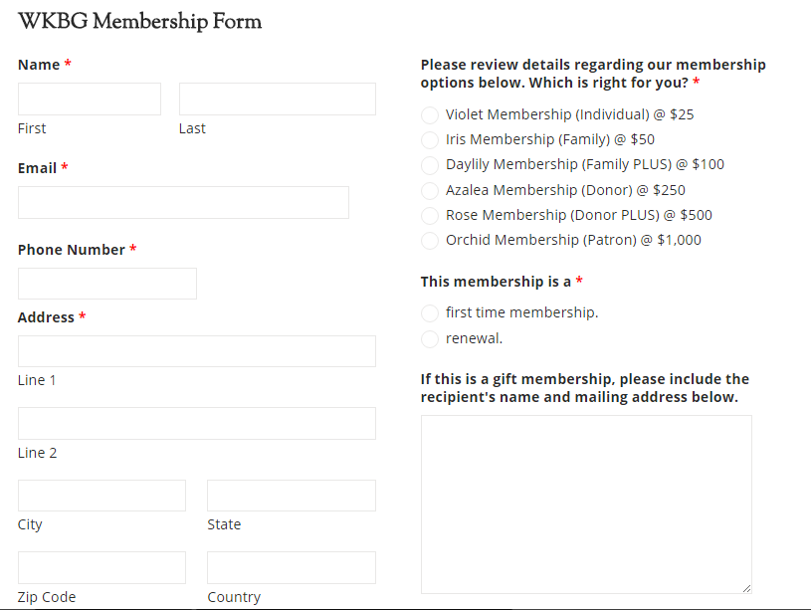

Membership has its privileges! Please review them @ http://www.wkbg.org/membership
Please mail this form in with your check made payable to The Western Kentucky Botanical Garden, to us at P.O. Box 22562, Owensboro, KY 42304

